Effort expended per finding (AEEF)

Metric definition
For a detail information on the metric operational definition refers to [SMP_AEEF.doc]

Data used

Only data generated after pilot start date was included on these analyses.

Excluded audits:

Audit ID | AEEF
00021661  00022404 | 7.69231  6.40000

Descriptive data
The following graph shows the summary statistics for the data (including: normality test, Sample size, confidence intervals, etc.). It gives a preliminary overview of data distribution and of the principal descriptive values of the data to be analyzed.

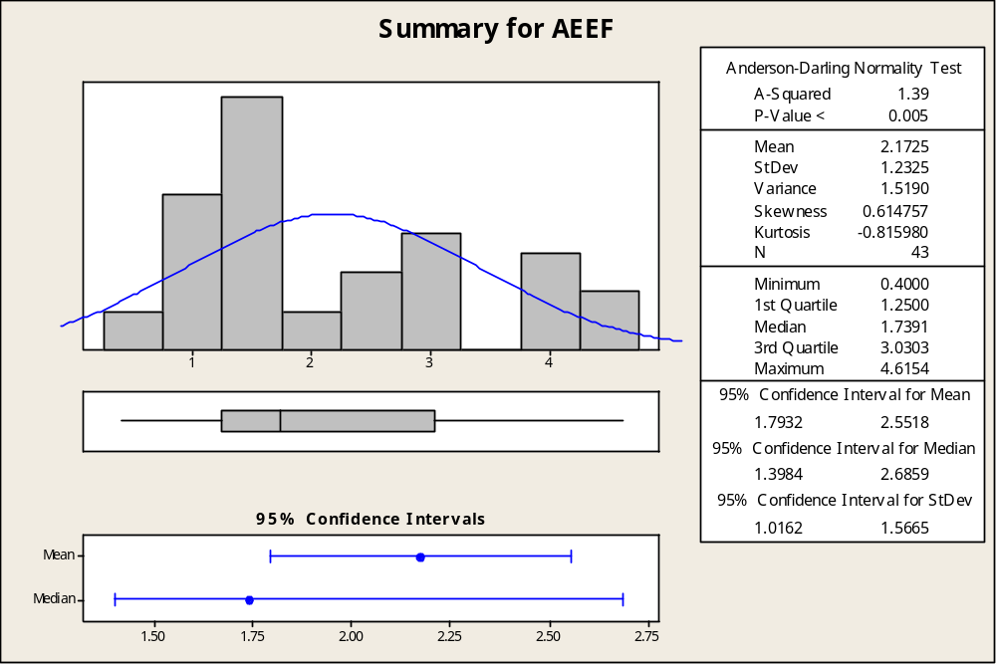

Stability analysis
As shown in the following graph, data is stable since special causes of variation are not present in the individual run chart.

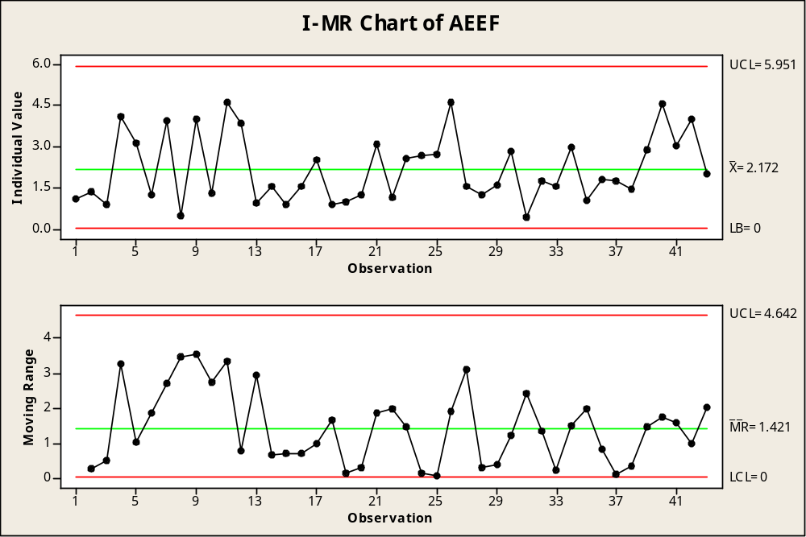

Distribution analysis
As shown in the following graph, there is enough evidence to suggest that data do not follow a normal distribution due to the fact that the p-value is not grater than 0.05 and in consequence the null hypothesis can be rejected (Ho: Data are normally distributed).

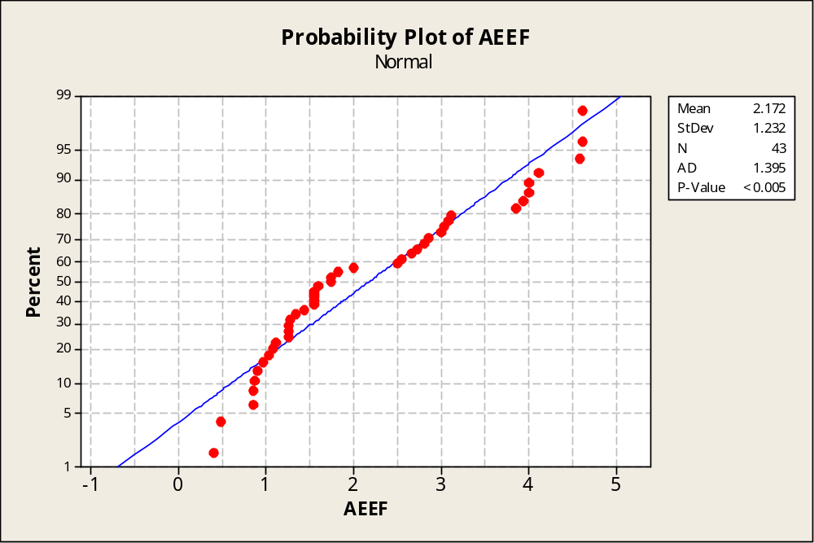

Further analysis was made to determine the underlying distribution of the data. As shown in the following table the Lognormal distribution best passed the fit test.

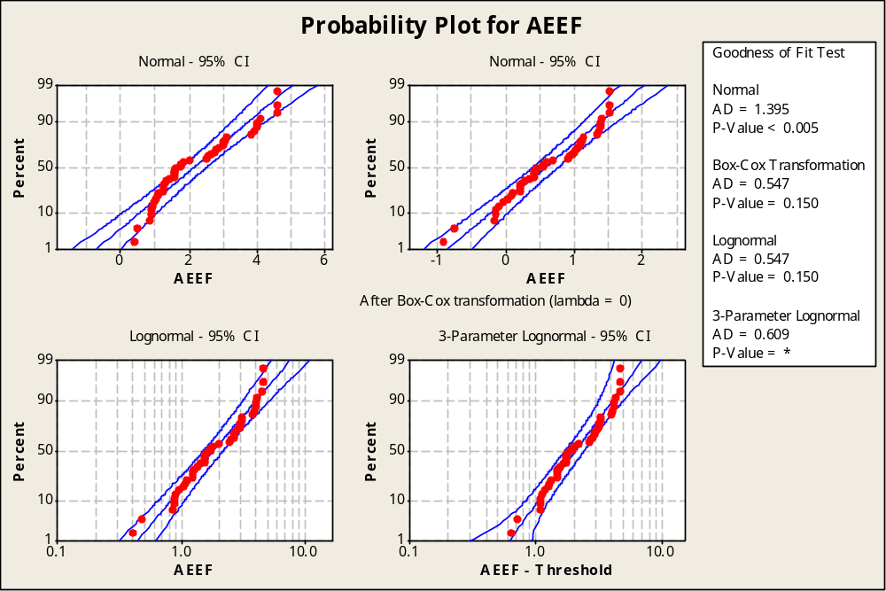
Goodness of Fit Test

Distribution AD P LRT P
Normal 1.395 <0.005
Box-Cox Transformation 0.547 0.150
Lognormal 0.547 0.150
3-Parameter Lognormal 0.609 * 0.567
Exponential 3.800 <0.003
2-Parameter Exponential 2.047 <0.010 0.000
Weibull 0.783 0.040
3-Parameter Weibull 0.579 0.139 0.129
Smallest Extreme Value 2.028 <0.010
Largest Extreme Value 0.883 0.022
Gamma 0.665 0.090
3-Parameter Gamma 0.554 * 0.409
Logistic 1.335 <0.005
Loglogistic 0.635 0.061
3-Parameter Loglogistic 0.622 * 0.864
Johnson Transformation 0.495 0.204

Capability Analysis
As shown in the following graph, the process is not capable of meeting the specification limits (as indicated by the Pp value of 0.13). See [OQP Plan] for a complete reference on the specification limits definition.

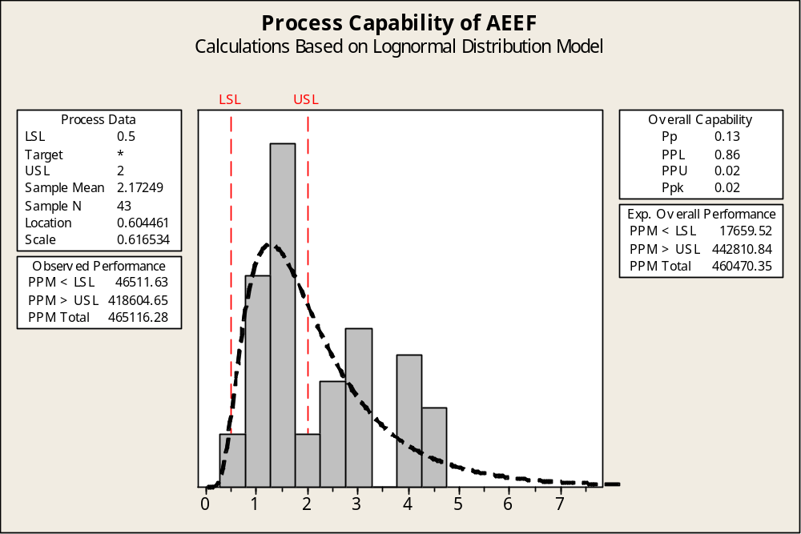

Metric Analysis Conclusion
Although the process is stable over the period of time measured, the process is not capable of achieving the expected performance. An important remark is that the 95 percent confidence interval for the mean AEEF is (1.7932 – 2.5518) therefore it is not between the specification limits.

Trend Analysis
Also analyses over the mean and the standard deviation were made in order to determine if there was significant improvement since last baseline.

The graphic below depicts a significant increase on the variability and the mean of the process compared with previous baseline.

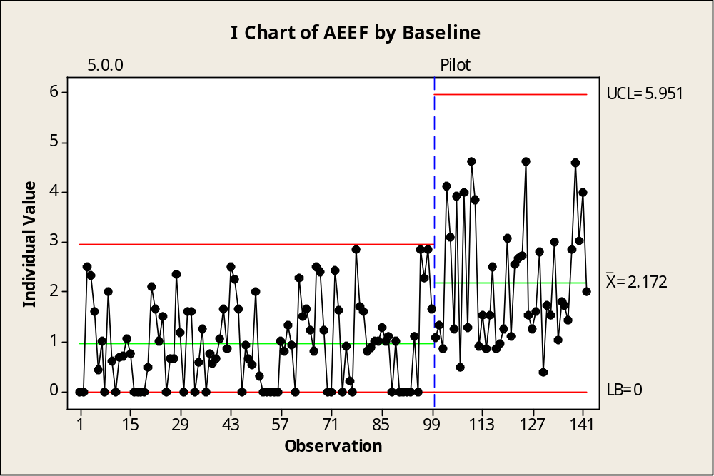

The following analyses showed that a statistically significant improvement was achieved.

Mann-Whitney Test and CI: AEEF_5.0.0, AEEF_Pilot

N Median
AEEF_5.0.0 99 0.8889
AEEF_Pilot 43 1.7391

Point estimate for ETA1-ETA2 is -1.0811
95.0 Percent CI for ETA1-ETA2 is (-1.5384,-0.7390)
W = 5842.5
Test of ETA1 = ETA2 vs ETA1 not = ETA2 is significant at 0.0000
The test is significant at 0.0000 (adjusted for ties)

As the p-value is not greater than 0.05 the null hypothesis can be rejected therefore the two samples medians can be considered as statistically (significantly) different.

CP AND CPK: The capability index Cp is a measure of the potential capability of a process. Cpk is measure of the actual capability (taking into account the centering of the process).

